Special Assignment-I

High Voltage Engineering(EE503)

**AIM:-** Simulate a 3 stage Cockroft Walton circuit for output voltage 300 kV. (using PSIM, MATLAB OR PSCAD). Capture waveforms and comment on all nodal voltages in the circuit and output voltage.

**Simulation Software:-** PSIM 9.0.3

**Components used in the Circuit:-**

1. Supply Voltage:- 50000 Volts, 50 Hz
2. Capacitors:- 0.6 mF
3. Diodes
4. Voltmeters, Ammeters
5. Load:- 2 Giga Ohms(For representing Dielectric Load)
6. Transformer:- 1:1 inverted polarity Transformer

**Circuit Diagram:-**

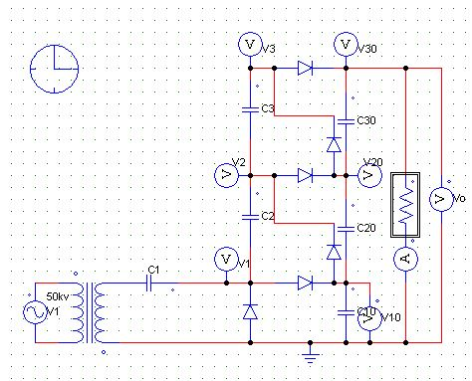

A 3-stage Cockroft Walton Circuit is shown in the above figure. The circuit uses Alternating Voltage to convert it into High Voltage DC.

The output Voltage would be= 2nVsc=2x3x50kv = 300 kv

The node voltages V1,V2 and V3 are called the oscillating Column Voltages, and the node voltages V01,V02 and V03 are called the smoothening Column Voltages.

However, the Output Voltage obtained is not perfectly constant as the voltage contains some ripple content.

**Various Waveforms:-**

Waveform of Voltages across oscillating Column:-

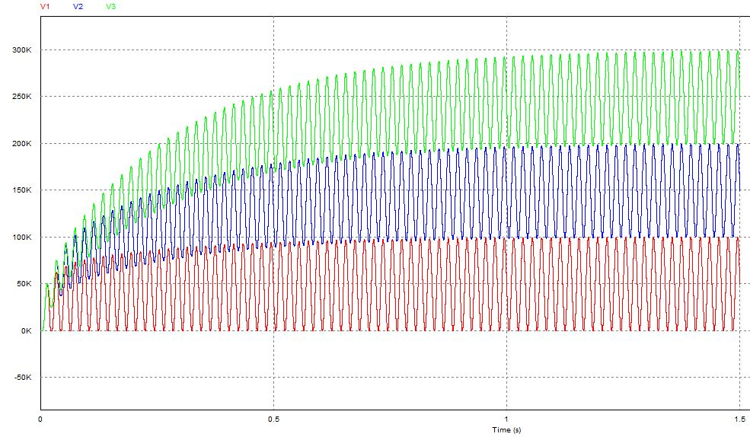

Observations:

* The voltages of the first stage of circuit oscillate between 0 to 2*1*50kv=100kv(where n=1).
* The voltages of second stage of circuit oscillate between and 100kv to 2*2*50kv=200kv(where n=2).
* The voltages of third stage of circuit oscillate between 0 to 2*3*50kv = 300kv(where n=3).

Waveforms of Smoothening Column Voltages:-

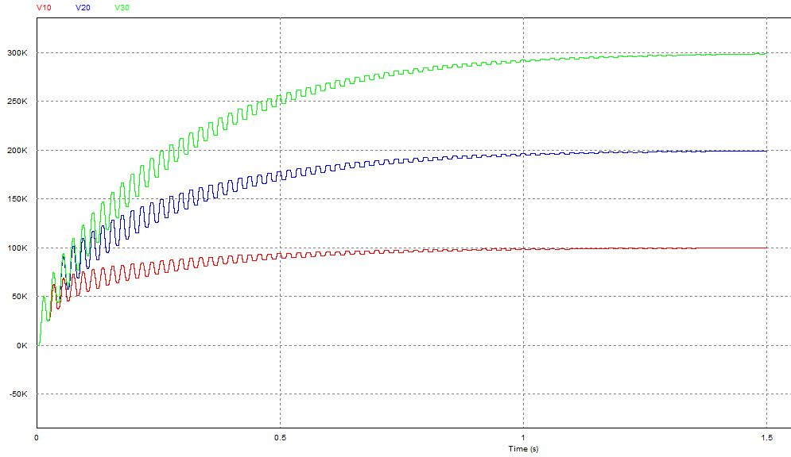

* Node Voltage at 1st stage of smoothening column:-2*1*50kv=100kv.
* Node Voltage at 2nd stage of smoothening column:-2*2*50kv=200kv.
* Node Voltage at 3rd stage of smoothening column:-2*3*50kv=300kv.

Output Voltage Waveform:-

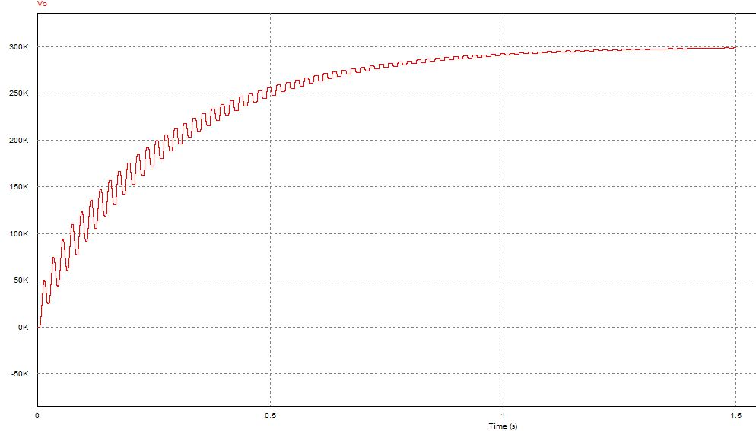

Vo=298,624.56 Volts (The difference in the output voltage is due to the ripple voltage.)

The ripple voltage can be reduced by increasing the frequency or by increasing the value of capacitor or reducing the load current.

**Conclusion:-**

The voltage generated using the Cockroft Walton Circuit is 2nVmax also the limitation of the circuit is the low value of load current.